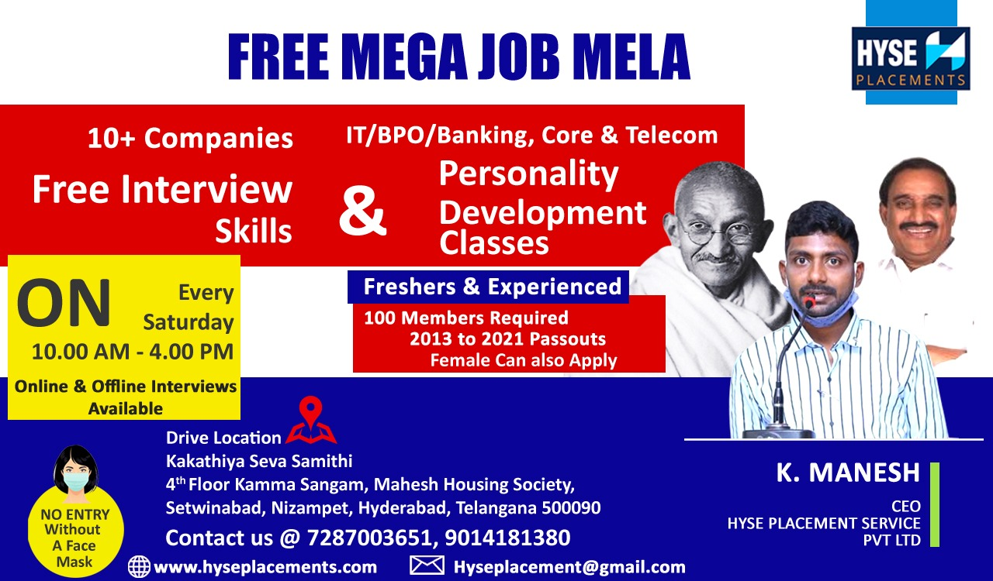

**HYSE Placements & Digital Academy**

**www.hyseplacements.com**

**www.hysedigitalacademy.guru**

**(All the below services are Free)**

**We Provide Training On 8 Domain's**

**(Java, UI+UX, Data Science+ Python+ AI+ ML, Testing, Digital Marketing, Content Writing, Spoken English+ MS Office+ MS Excel+ Communication Skills, Interview Preparation+ Personality Development)**

**Courses & Their Timings**

**JAVA**

**Morning batch- 7AM to 8:30AM**

**Evening batch - 7:00PM to 8:30PM**

**DIGITAL MARKETING**

**Morning batch : 9:00 AM to 10:30AM**

**Evening batch : 6:00PM to 7:30PM**

**CONTENT WRITING**

**Only Evening batch :**

**8:00 PM to 9:00PM**

**DATA SCIENCE**

**Morning : 7Am to 8Am**

**Evening : 7Pm to 8Pm**

**TESTING**

**Morning batch : 8:30AM to 10:00AM**

**Evening : 8:30PM to 10;00pm**

**UI&UX**

**Morning : 8Am to 9Am**

**Evening : 8Pm to 9pm**

**Interview skills , Resume Making & personality development**

**For Non IT Students : 4PM to 5PM**

**For IT Students**

**3Pm to 4PM**

**Ms excel + Ms office**

**+ communication skills + spoken English**

**Morning batch -**

**9:00 AM to 10:00 AM**

**Evening Batch - 5pm to 6pm**

**We Provide Training + Internship + Working live Project + Internship + certification + Job Assistance .**

**Interview skills , Resume Making & personality development**

**For Non IT Students : 4PM to 5PM**

**For IT Students**

**3Pm to 4PM**

**Ms excel + Ms office**

**+ communication skills + spoken English**

**Morning batch -**

**9:00 AM to 10:00 AM**

**Evening Batch - 5pm to 6pm**

**3Months Courses**

**Weekly 5Days Monday To Friday**

**Daily 90Mints Technical Training**

**Morning & Evening Batch Available**

**We Provide Every Month Free Training For 600 Students on Different IT Domains**

**We Provide Top 6 Companies Interviews on 3rd Month of Training period .**

**Rules and Criteria To join our Academy**

**Should Have 50% In last Academic year**

**Should have minimum 70+% To receive placement assistance or certificate**

**Important Note**

**We are providing Part time work for our Training Students where they can earn 5000rs to 10000rs per Month**

**By working 1Hour On Online**

Complete Java Course Topics

Duration : 4-5 Months

**Core Java**

1. What Is Java
2. Features of Java
3. Java Variables
4. Java Data Types
5. Operators
6. Keywords

**Control Statements**

1. If-Else
2. Switch
3. For Loop
4. While Loop
5. Do-While Loop
6. Break
7. Continue

**Java Object Classes**

1. OOPs Concepts
2. Object & Classes
3. Method
4. Constructor
5. Static keyword
6. This keyword

**Java Polymorphism**

1. Method Overloading
2. Method Overriding
3. Super keyword
4. Final keyword
5. Final class,variable

**Java Abstraction**

1. Abstract Class
2. Interface
3. Abstract vs Interface

**Java Encapsulation**

1. Packages
2. Access Modifiers
3. Encapsulation

**Exception**

1. Exception and error
2. Types of exceptions
3. Types of keyword

**Java Collection**

1. Collection interface
2. Implantation classes
3. Set

1)Hashset

2)linkedHashset

1. Map

1)HashMap

2)Hashtable

3)LinkedHashMap

1. List

1)ArrayList

2)LinkedList

3)Vector

1. Iterating through collection
2. Iterator
3. ListIterator

**Java 8**

1. Java 8 Features
2. Java 8 Lambda Expression
3. Java 8 Functional Interfaces
4. Java 8 Method References
5. Java 8 Stream API
6. Java 8 Optional Class
7. Java 8 Collector Class
8. Java 8 Static and Default Methods
9. Java 8 StringJoiner Class

**Adv Java(J2EE- Servlet,JSP,JDBC)**

1. Servlet Life Cycle
2. Servlet Interface Example
3. Generic Servlet Class
4. HttpServlet Class
5. HttpServlet Methods(doGet,doPost,doDelete…)
6. @WebServlet,@WebInitParam,@WebListener,@WebFilter
7. JSP(Java Server Pages) Overview
8. How JSP Works
9. Scripting Elements
10. Expression Tags
11. Scriptlets
12. Implicit Objects
13. Directives(page,include,taglib)
14. Jsp Action
15. JSP- Processing HTML Form Data
16. JSP Custom Tag Development

# Spring Introduction

1. Spring Life cycle
2. Spring Bean Scopes
3. Spring Modules
4. Spring IOC and DI
5. Spring MVC
6. Spring Multiple View Page
7. Spring Multiple Controllers
8. Model Interface
9. Spring File Upload Example
10. Spring Security
11. Spring Transaction
12. Spring ORM
13. Integration Spring With Hibernate
14. Integration Spring With JSF 2.0

**Hibernate**

1. Hibernate Introduction
2. First Hibernate Example
3. HB Generator Classes
4. Inheritance Mapping
5. Table Per Class
6. Table Per SubClass
7. Table Per Concrete Class
8. Hibernate Mapping
9. Mapping List
10. Mapping Set
11. Mapping Map
12. One to One XML
13. One to One Annotation
14. One to Many XML
15. One to Many Annotation
16. Many to Many XML
17. Many to Many Annotation
18. TX Management
19. HQL
20. Named Query
21. Hibernate Caching (First and Second Level)

# Springboot Introduction

1. Springboot Introduction
2. Difference between Springboot and SpringMVC
3. Creating Springboot Project with SpringInitializer
4. Installing Springboot Project with Maven
5. Springboot HelloWorld Example
6. Overview of Springboot Starter Parent
7. Springboot Annotations
8. Springboot with Hibernate/JPA
9. SpringbootPathVariable,RequestBody,ResponseBody and ResponseStatus
10. One Application using Springboot + JSP + Hibernate +MySql

**Strus 1.3**

1. Struts Introduction
2. Struts Architecture
3. Struts Basic Example
4. Struts Action Form

1) ActionForm

2) DynaActionForm

3) DynaValidatorForm

1. Struts Action Classes
2. Action
3. DispatchAction
4. lookupdispatchAction
5. forwardAction
6. MappingDispatchAction
7. Validation

**www.hyseplacements.com**

**www.hysedigitalacademy.guru**

|  |
| --- |
| **“Thank you, Looking forward to Hear from You.”** |
|